**PSY 652 Lab: Module 3 Activity**

**September 18, 2019**

The following exercises are intended to provide hands-on practice conceptualizing how different types of Questionable Research Practices (QRPs) impact study results and biases in published literature. While many types of QRPs exist, here we’ll specifically focus on two types of HARKing: Cherry Picking and Question Trolling. We’ve included two tables from Murphy & Aguinis’ 2019 article that used simulations to examine how Cherry Picking and Question Trolling impact statistical results. Answer the questions below using the tables and provided terms.

***Note:*** *Without HARKing, the true parameter for the average correlation coefficient (mean r) across studies is .20 in these simulations.*

**Definitions of key terms:**

1. ***QRPs:*** Questionable Research Practices
2. ***HARKing:*** Hypothesizing After Results are Known
3. ***Forms of HARKing:*** 
   1. *Cherry Picking:* Involves searching through data that includes alternative measures or samples to find the results that offer the strongest possible support for a particular hypothesis or research question a study was designed to investigate. *Tends to be associated with a more homogenous set of effects in the published literature*.
   2. *Question Trolling:* Involves searching through data that includes several different constructs, interventions, or relationships to find seemingly notable results. *Tends to be associated with more heterogeneous sets of effects in the published literature.*
4. ***Sample Size:*** The number of participants included in a study.
5. ***Pool Size:*** The total number of statistical tests a research team conducts and chooses from when selecting results to publish (e.g., if a researcher conducts 10 tests and elects to only publish the one test that detected the largest effect size, pool size = 10; if a researcher conducts 2 tests and elects to only publish the test that detected a larger effect size, pool size = 2).
6. ***QRP Prevalence:*** The percentage of studies that employed a specific type of QRP. In the studies included below, QRP prevalence was specified as a simulation parameter.
7. ***Mean r:*** The average correlation coefficient reported across a set of studies. In this case, mean r is our proxy for effect size, where larger r values reflect larger effect sizes.
8. ***Question Trolling Heterogeneity* (aka effect size SD)**: In this context, effect size SD represents the upper bound for variability in effect sizes in each set of studies. The more haphazardly a research team trolls for questions (i.e., the more variable relationships they examine), the more variability they will observe in effect sizes (i.e., a wider range of effect sizes to choose from when selecting results to publish).

***Section 1: Impact of cherry picking results***

*Below are results from Murphy & Aguinis’ (2019) HARKing simulation.*

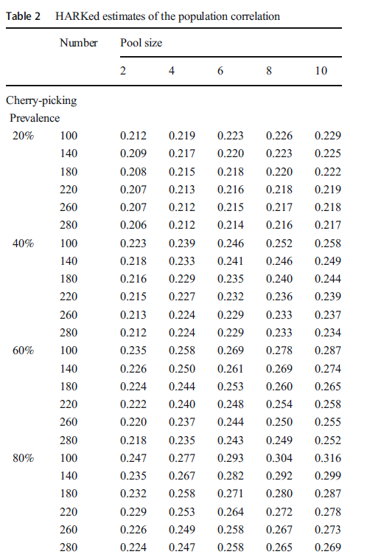

1. Conceptually, what does this table demonstrate?
   1. Why does mean r tend to increase with increasing pool size?
   2. Why does mean r tend to decrease with increasing sample size?
   3. What is the impact of increasing cherry picking prevalence?

_________________________________________________________________

**Section 2: Question Trolling**

*Below are results from Murphy & Aguinis’ (2019) HARKing simulation.*

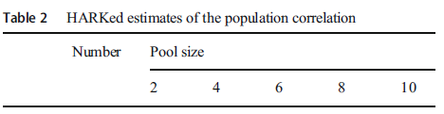

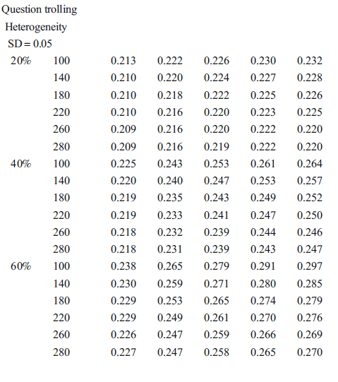

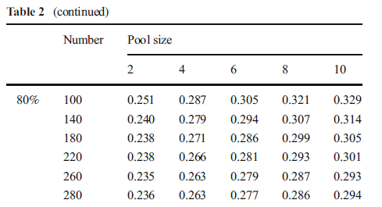



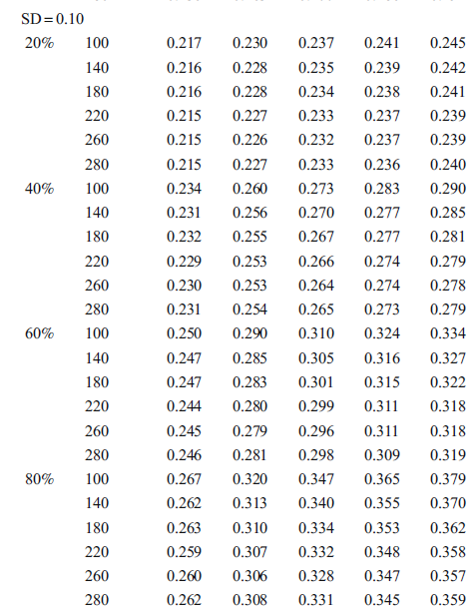



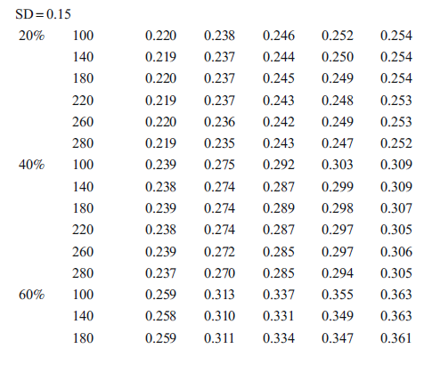

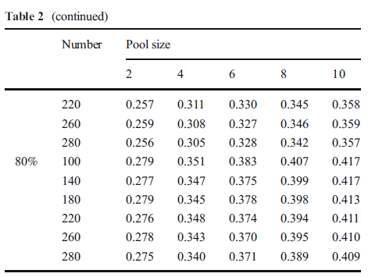

2. Conceptually, what does this table demonstrate?

* 1. Why does mean r tend to increase with increasing pool size?
  2. Why does mean r tend to decrease with increasing sample size?
  3. What is the impact of increasing question trolling prevalence?
  4. Why is it useful to include Question Trolling Heterogeneity (effect size SD) in the question trolling simulation?
  5. What happens as the Question Trolling Heterogeneity (effect size SD) increases?

3. What four factors affect the impact of bias produced from Cherry Picking & Question Trolling?

4. Based on these tables, is Cherry Picking or Question Trolling more likely to be introducing biases into published literature? How did you reach your conclusion?

5. What are three ways that researchers, editors, and journals can respond to QRPs and the current “reproducibility crisis” in published literature?